CA1-CAP770
Name – Prashant Patil
Roll No- 24
Reg no- 12527088
Group – 1

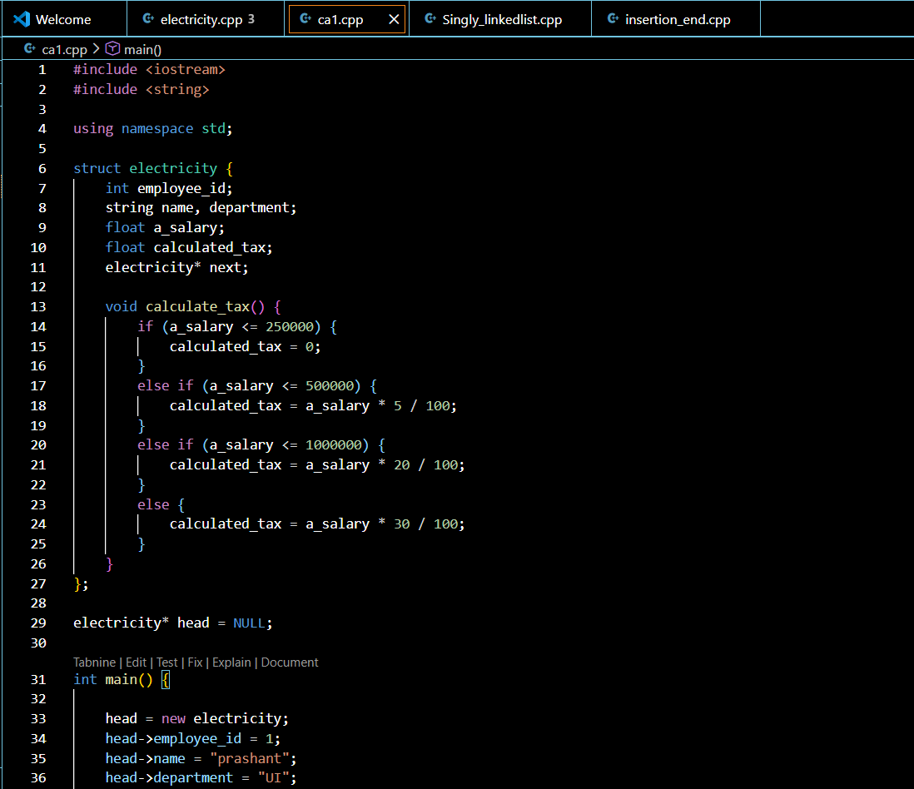

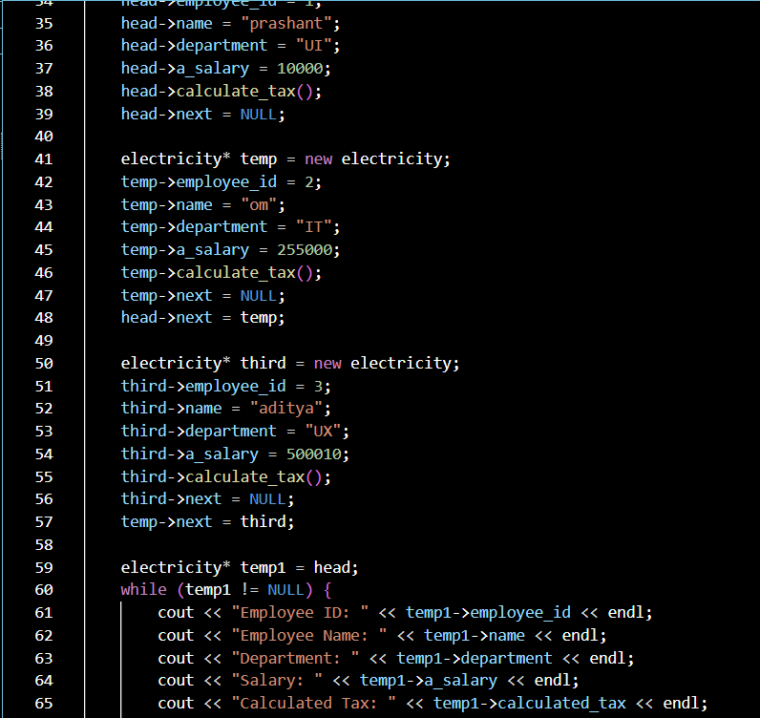
OUTPUT-s
